**Mediplus Lite**

**LAUNCHING EC2-INSTANCES**

* Number of Instances – 2 [ 1.Jenkins server. 2.Docker server ]
* Applicationand OS images (Amazon machine image **) – UBUNTU**
* Select Ubuntu server 24.04 LTS (HVM), SSD volume type.
* Instance type – **T2 MEDIUM**
* Create a new key pair. (ppk file )
* Set up the VPC & SUBNETS – Default
* Create a new Security group
* Allow the SSH , HTTP & HTTPS
* Now adjust the storage(volumes) from 8Gb – 10Gb

Ref image

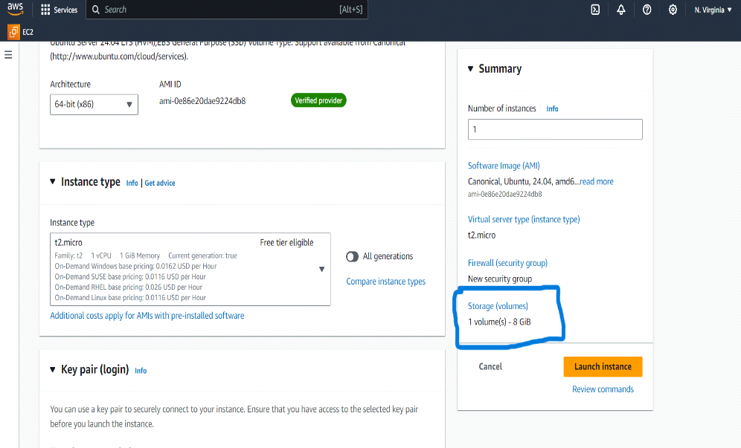

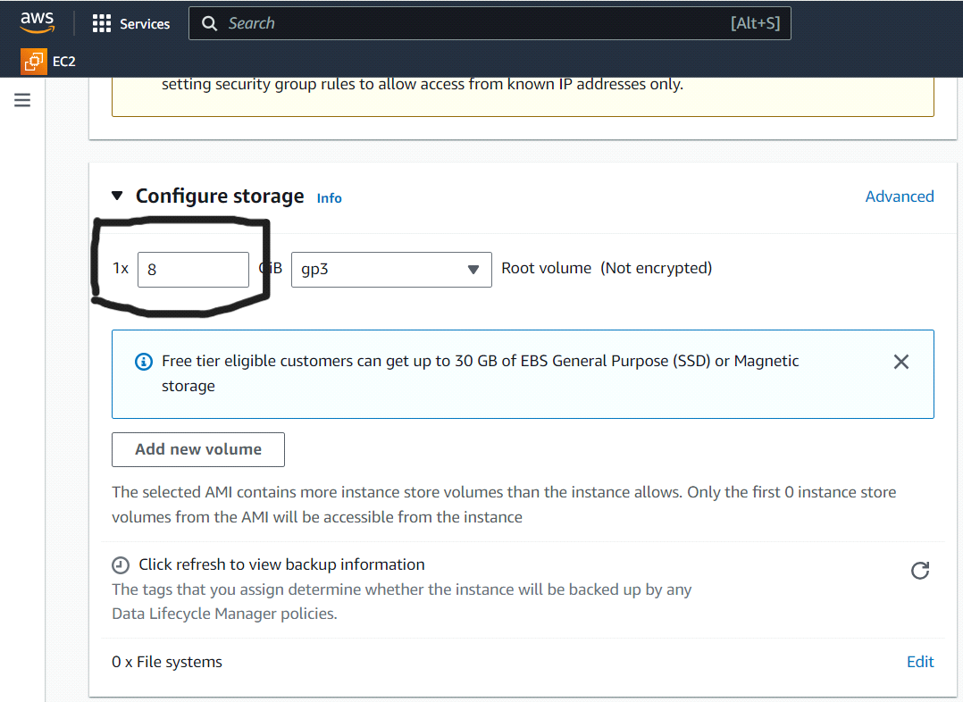

* **LAUNCH INSTANCE**
* **GO TO GOOGLE SEARCH BAR AND SEARCH FOR FREE CSS TEMPLATES**
* [**https://www.free-css.com/free-css-templates**](https://www.free-css.com/free-css-templates)
* Download any one CSS template and Extract file ( with WINRAR application)
* GO TO GIT HUB AND CREATE A NEW REPO

Ref image

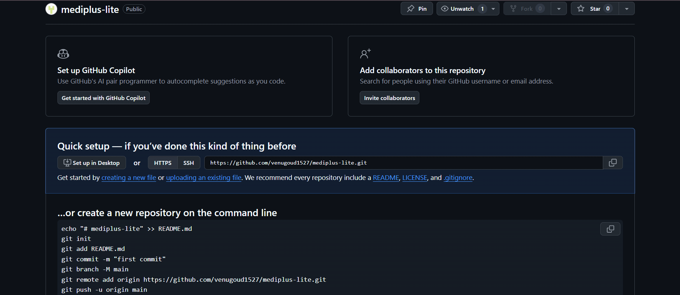

* Select UPLOADING AND EXISTING FILE
* Drag your downloaded CSS files into REPO
* COMMIT THE CHANGES
* Create a new Docker file in GitHub

Ref Image:

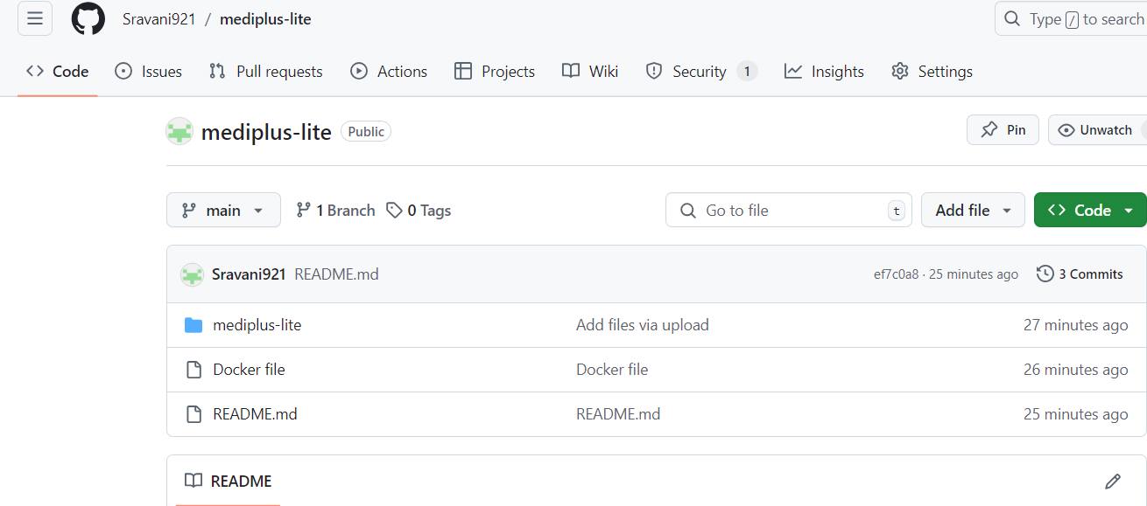

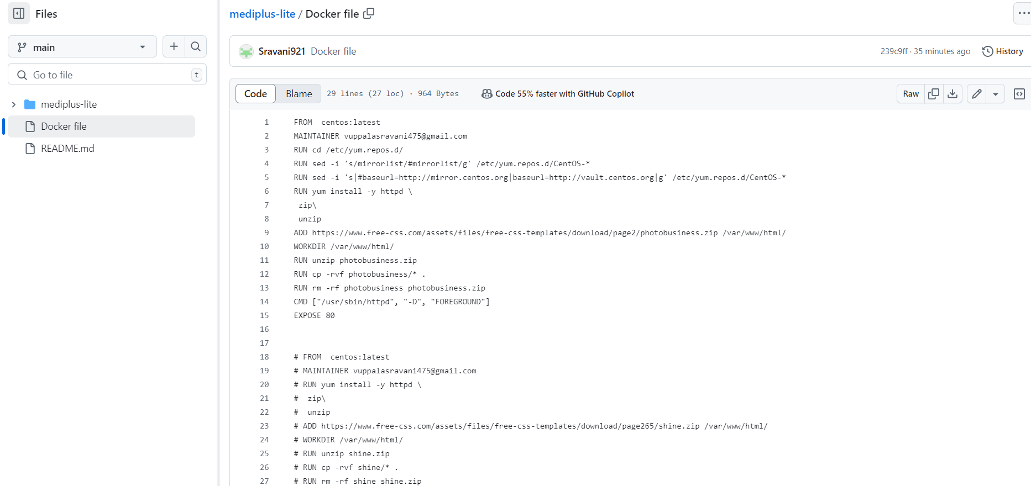

* COMMIT THE CHANGES
* Go to the Console and start the instances using putty and public IP address of servers

Ref Images: 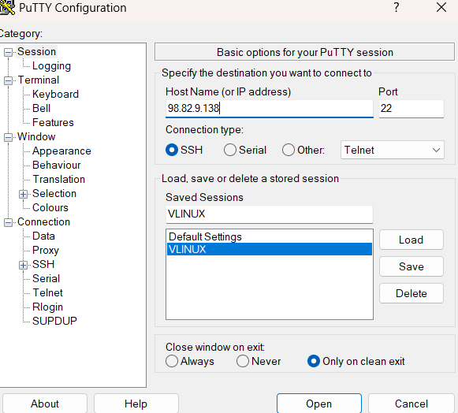

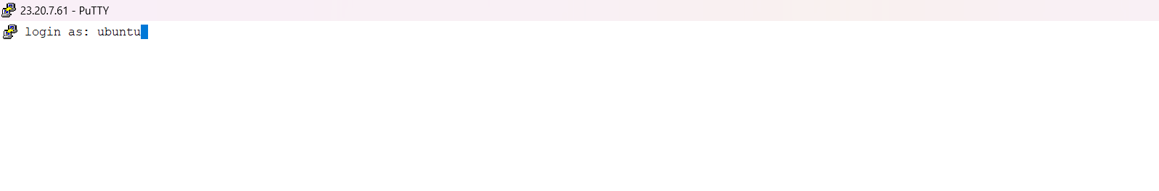

* **INSTALL THE JENKINS AND JAVA ON JENKINS SERVER(SERVER1)**
* [**https://www.jenkins.io/doc/book/installing/linux/#debianubuntu**](https://www.jenkins.io/doc/book/installing/linux/)
* sudo wget -O /usr/share/keyrings/jenkins-keyring.asc \
* <https://pkg.jenkins.io/debian-stable/jenkins.io-2023.key>
* echo "deb [signed-by=/usr/share/keyrings/jenkins-keyring.asc]" \
* [https://pkg.jenkins.io/debian-stable binary/](https://pkg.jenkins.io/debian-stable%20binary/) | sudo tee \
* /etc/apt/sources.list.d/jenkins.list > /dev/null
* sudo apt-get update
* sudo apt-get install Jenkins
* **INSTALLING THE JAVA**
* sudo apt update
* sudo apt install fontconfig openjdk-17-jre
* java -version
* openjdk version "17.0.8" 2023-07-18
* OpenJDK Runtime Environment (build 17.0.8+7-Debian-1deb12u1)
* OpenJDK 64-Bit Server VM (build 17.0.8+7-Debian-1deb12u1, mixed mode, sharing)
* sudo snap install openjdk

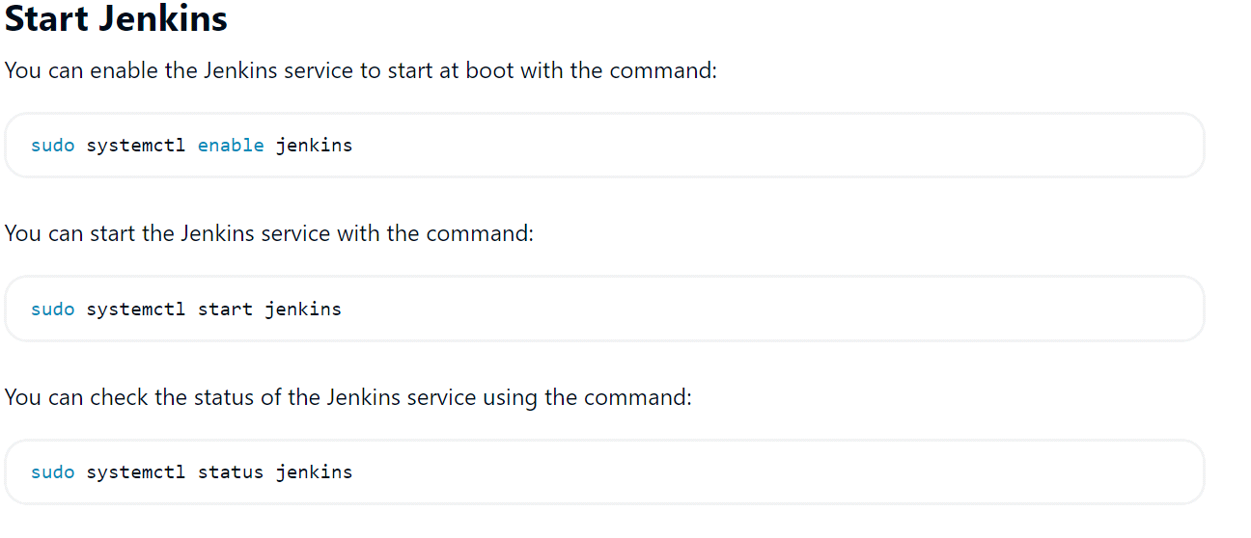

* In Inbound rules ADD NEW RULE Allow port range 8080

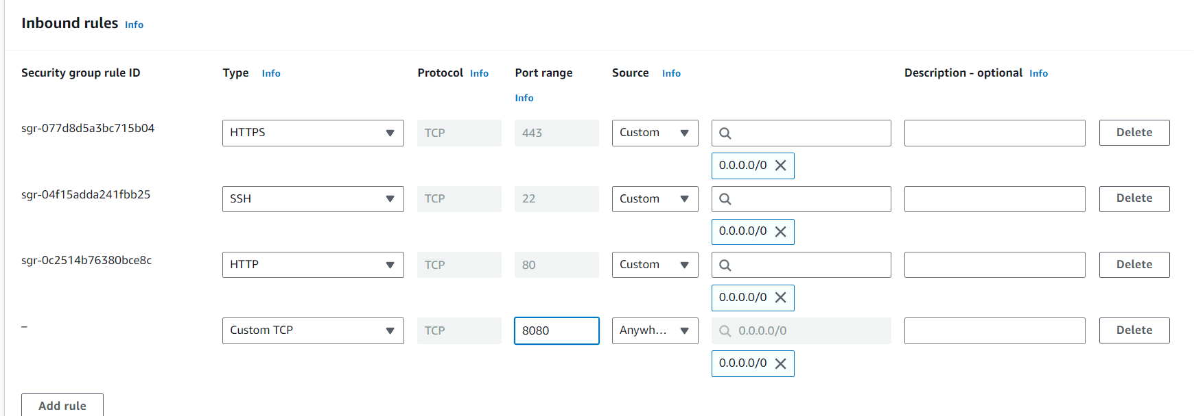

* Connect to the Jenkins Dashboard.
* **INTALL ANSIBLE IN JENKINS SERVER (SERVER1):**
* [**https://docs.ansible.com/ansible/latest/installation_guide/installation_distros.html#installing-ansible-on-ubuntu**](https://docs.ansible.com/ansible/latest/installation_guide/installation_distros.html)
* sudo apt update
* sudo apt install software-properties-common
* sudo add-apt-repository --yes --update ppa:ansible/ansible
* sudo apt install ansible0ee22
* sudo hostnamectl set-hostname jenkins
* /bin/bash
* sudo apt install python3-pip
* pip install docker --break-system-packages
* cd /etc/ansible
* ls
* sudo vim hosts

Ref Image:

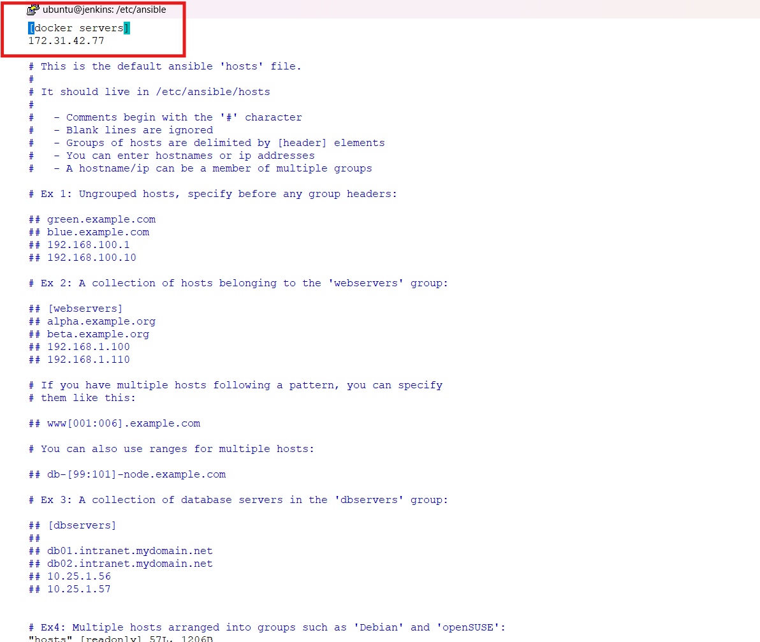

**NOTE :** Add the docker server private IP address as shown above and save the file.

* Save the changes wq!
* ubuntu@172.31.46.63:/etc/ansible$ cd ~
* ubuntu@172.31.46.63:~$ sudo hostnamectl set-hostname Jenkins
* ubuntu@jenkins:~$ sudo su
* ubuntu@jenkins:/home/ubuntu# su Jenkins
* ubuntu@jenkins:/home/ubuntu$ cd ~
* jenkins@jenkins:~$
* mkdir playbooks
* cd playbooks/
* ssh-keygen

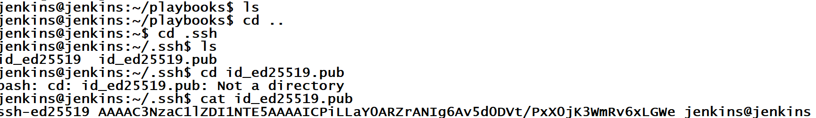

* GO TO SERVER 2 AND CONNECT AND INSTALL DOCKER
* Sudo apt-get update
* sudo apt-get install ca-certificates curl
* sudo install -m 0755 -d /etc/apt/keyrings
* sudo curl -fsSL [https://download.docker.com/linux/ubuntu/gpg HYPERLINK "https://download.docker.com/linux/ubuntu/gpg%20-o%20/etc/apt/keyrings/docker.asc" -o /etc/apt/keyrings/docker.asc](https://download.docker.com/linux/ubuntu/gpg%20-o%20/etc/apt/keyrings/docker.asc)
* sudo chmod a+r /etc/apt/keyrings/docker.asc

# Add the repository to Apt sources:

* echo "deb [arch=$(dpkg --print-architecture) signed-by=/etc/apt/keyrings/docker.asc] <https://download.docker.com/linux/ubuntu> \ $(. /etc/os-release && echo "$VERSION_CODENAME") stable" | sudo tee /etc/apt/sources.list.d/docker.list > /dev/null
* sudo apt-get update
* sudo apt-get install docker-ce docker-ce-cli containerd.io docker-buildx-plugin docker-compose-plugin
* docker ps
* we get the error so called permissions denied
* sudo usermod -aG docker ubuntu
* newgrp docker
* docker ps
* sudo su
* ssh-keygen
* cd ~
* ls –la
* cd .ssh
* ls
* vim autherized-keys(need to comment and copy the ssh keyof jrenkins server to docker server)

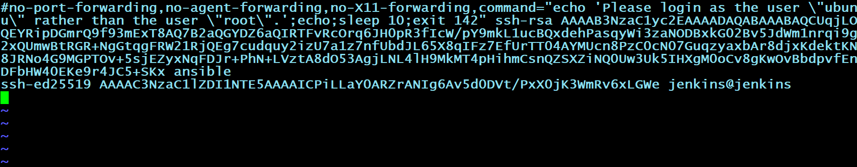

* sudo systemctl reload ssh
* Go to Jenkins server and connect docker server from here
* ssh root@Public IP Address of Docker Server
* exit
* ls
* cd ..
* cd playbooks/
* nano deployment .yaml

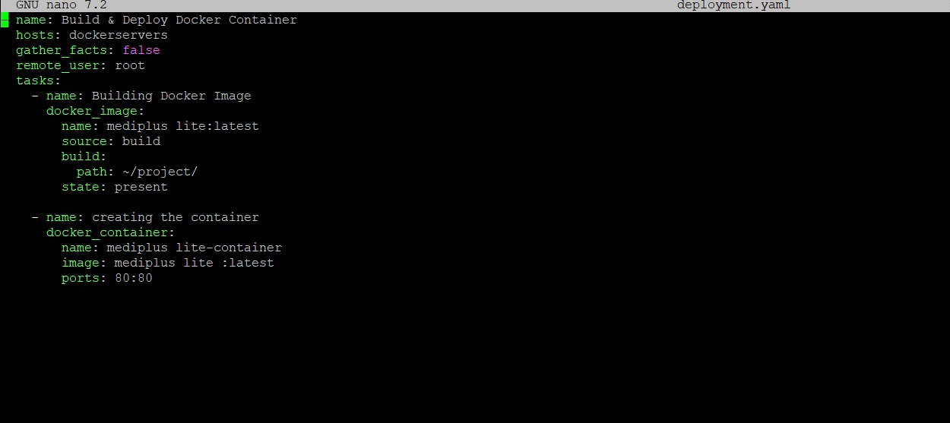

* Save the file by clicking cntrl+x
* Then Enter Y
* After y entry then again ENTER . it will SAVE.
* **GO TO THE JENKINS SERVER**
* Create a Free Style Project (Mediplus-lite).
* Go to the source code Management

Ref Image:

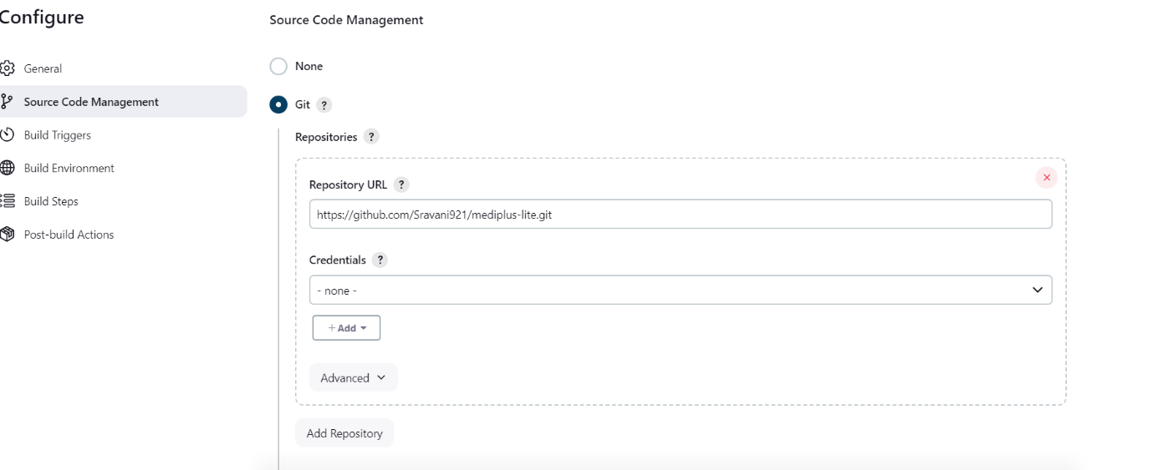

* Apply and Save
* BUILD NOW
* After your job successfully done . Go to the GitHub and Add Webhook

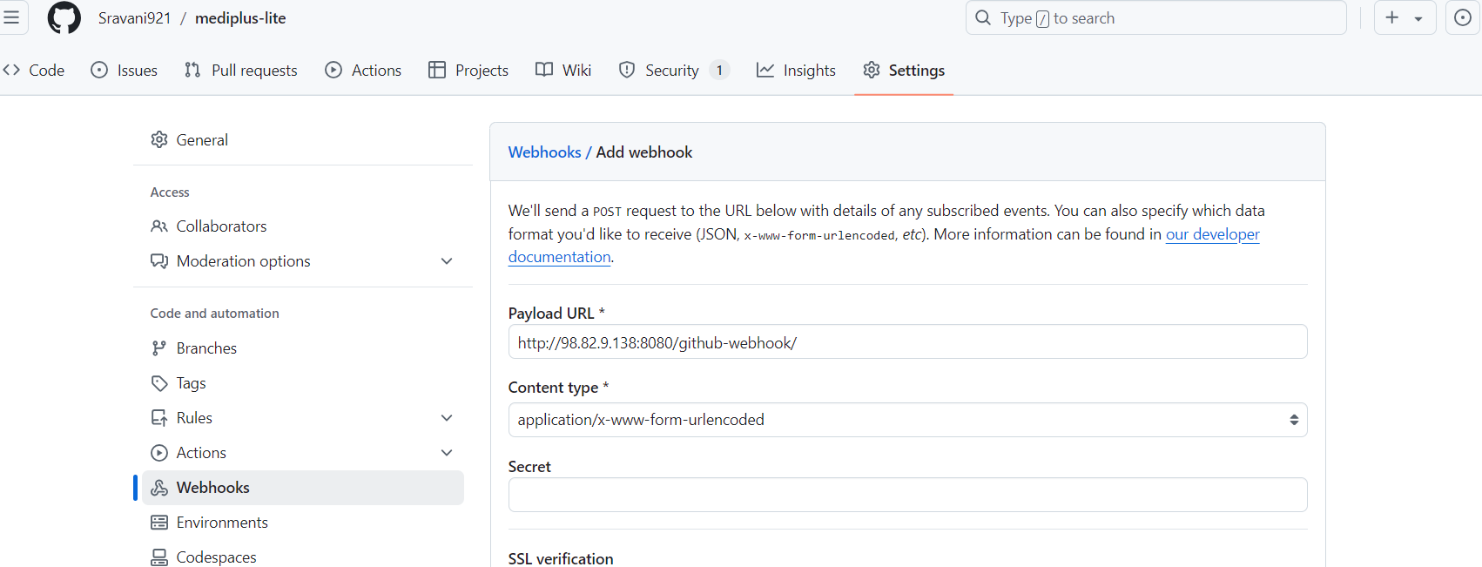

* Copy the Jenkins URL and paste in webhook as shown in the above image
* Select Let me select individual events.
* Select Pull Requests and Pushes

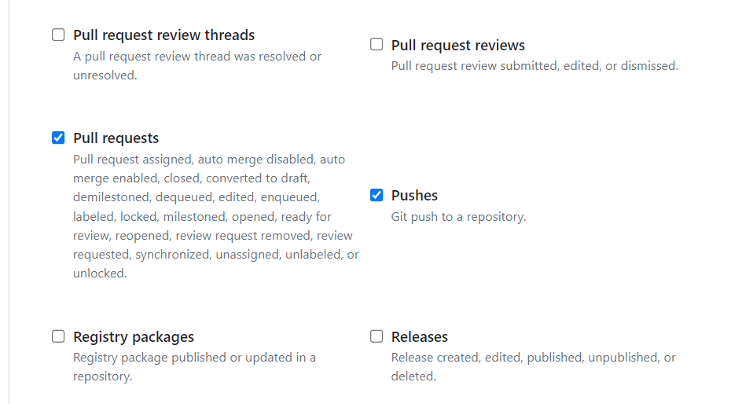

* Add webhook
* In GitHub go to your REPO codes and open your Docker File and make some changes and commit the changes

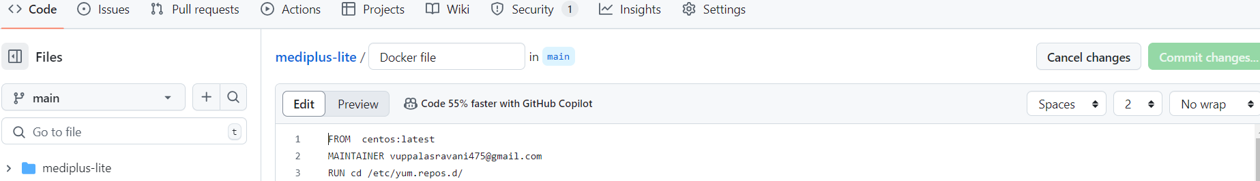

* Go to Jenkins dashboard and your project configure.
* Select build triggers – GitHub hook trigger for GITSCM polling
* BUILD NOW
* Now, Go the Jenkins server instance terminal
* jenkins@jenkins:~/playbooks$ scp -r /var/lib/jenkins/workspace/mediplus lite/

root@ 172.31.42.77:~/project/

NOTE: Private IP Address of the Docker server.

OUTPUT: 